11)where do we use MongoDB

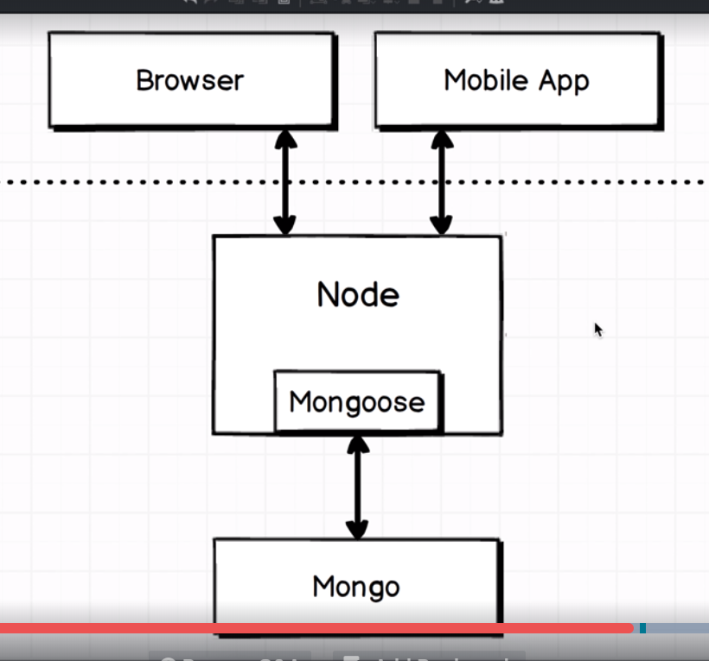mongoose is ORM. Monggose is somrthing that allow us to work with our database in much easier fashion that if we are using core mongo api’s. we will sometimes work with mongo directly but for most part we will be working with mongoose because it is industry standard.

12)Fundamentals of MongoDb

Mongo bases all its data storage around 2 different ideas, first is mongo allows to have multiple internal databases inside of a single mongo instance. The purpose of this is to allow us to work on different projects without having to dump all data. We usually do not use multiple databases inside a single application

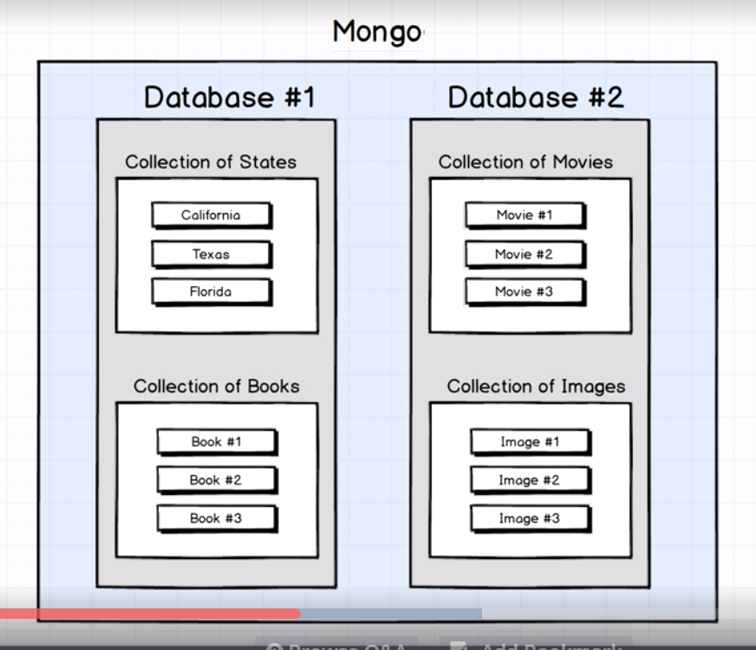

Reason I mentioned this, is because it introduces a little bit of confusing terminology. We refer to mongo as our database but we are also going to refer to each of these instances as databases as well .so I want to be clear about terminology. In most of cases database refers to one of these instances.

Now whats inside a data base.

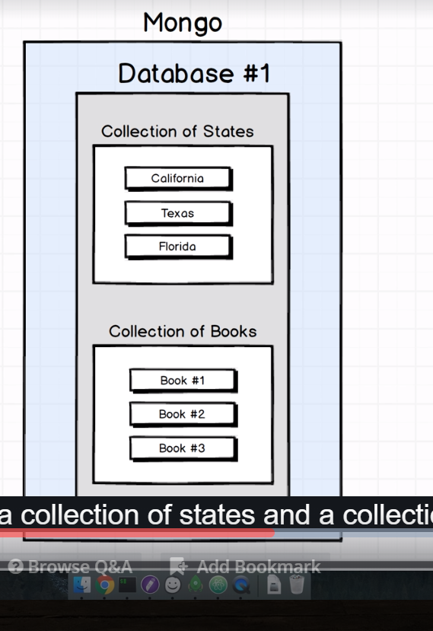

Inside diagram I have reflected,collection of states and collection of books. The collection is core unit of what stores data inside of mongo database. Traditionally we have one collection for each type of resource that we might need to make avalaible in our application. If I am making app of states and books then I will have 2 collections- states and books. We will not mix any type of data inside our collection.in other works I wnt take a state and put it in books.

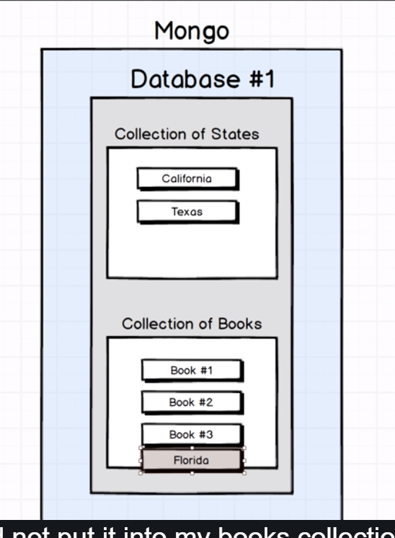i

It is a state not a book. So I will not put it inside books collections.

13)A Last touch of setup

In last lecture we saw 2 core principles of mongo database-

1)a single mongo database can have multiple internal databases

2)inside each of these databases we can have multiple collections.

So now we will look into crud operations-

Create, Read,update,delete

Our first project is going to be gain mastery over these 4 crud operations.